TEST cases document

CAMPSITE API CHALLENGE
february 10, 2019

Team Member(s)
Tarcisio Franco de Carvalho

Contents
1 INTRODUCTION 4
1.1 Purpose and Scope 4
1.2 Points of Contact 4
2 CAMPSITE AVAILABILITY API TEST CASES 5
2.1 Test case 1: Missing start or end date parameter 5
2.2 Test case 2: Parameter start and end date type format mismatch 6
2.3 Test case 3: Return properly available dates 7
3 CAMPSITE RESERVATION API TEST CASES 8
3.1 Test case 1: Max reservation days exception 8
3.2 Test case 2: Request reservation for minimum 1 day(s) ahead of arrival and up to 1 month in advance 9
3.3 Test case 4: Passed a non-valid booking identifier exception 11
3.4 Test case 5: Requested reservation dates not available exception 12
3.5 Test case 6: Request reservation 13
3.6 Test case 7: Request reservation update 15
3.7 Test case 7: Cancel reservation 16
3.8 Test case 8: Multiple reservation requests for the same/overlapping date 17

Revision History
Version | Date | Name | Description
1 | 2019/02/10 | Tarcisio Carvalho | Initial Document

INTRODUCTION

Purpose and Scope
This document shows the test cases results for campsite API

Points of Contact
Software developer: Tarcisio Franco de Carvalho – tarcisiofcarvalho@yahoo.com.br

campsite availability api test cases
The objective of the availability API is to provide the list of available dates for reservation considering a given date range.

Test case 1: Missing start or end date parameter

Requirement
This API expects two parameters, startDate and endDate, or no one parameter where one month will be considered as default. If just one parameter is passed, the API should return a clear exception message.

Expected result
- HTTP status code: 406 Not Acceptable
- JSON response: {
"status":"NOT_ACCEPTABLE",
"exceptionType":"Missing Parameter Exception",
"message":"Missing start or end date parameter"
}

Actual result
- Execution date: 2019-02-10 11:01
- API URI: http://ec2-3-17-129-161.us-east-2.compute.amazonaws.com:8080/api/v1/availabilities/?endDate=2019-03-05
- Result: Passed
- Screenshot
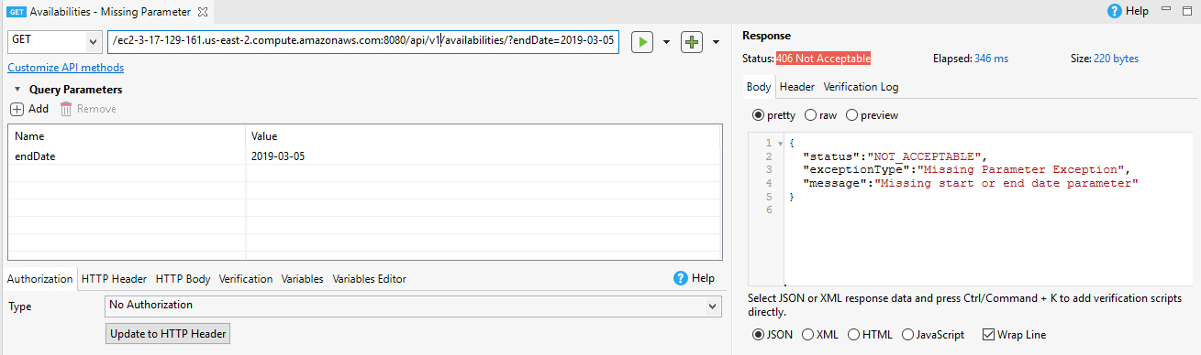

Test case 2: Parameter start and end date type format mismatch

Requirement
This API expects start and end date parameters in the format yyyy-MM-dd. If a different date format is passed, the API should return a clear exception message.

Expected result
- HTTP status code: 400 Bad Request
- JSON response:
{
"status":"BAD_REQUEST",
"exceptionType":"TypeMismatch Exception",
"message":"Unparseable date: \"2019.02.01\""
}

Actual result
- Execution date: 2019-02-10 11:12
- API URI: http://ec2-3-17-129-161.us-east-2.compute.amazonaws.com:8080/api/v1/availabilities/?startDate=2019.02.01&endDate=2019-03-05
- Parameter with wrong format: startDate:2019.02.01
- Result: Passed
- Screenshot:

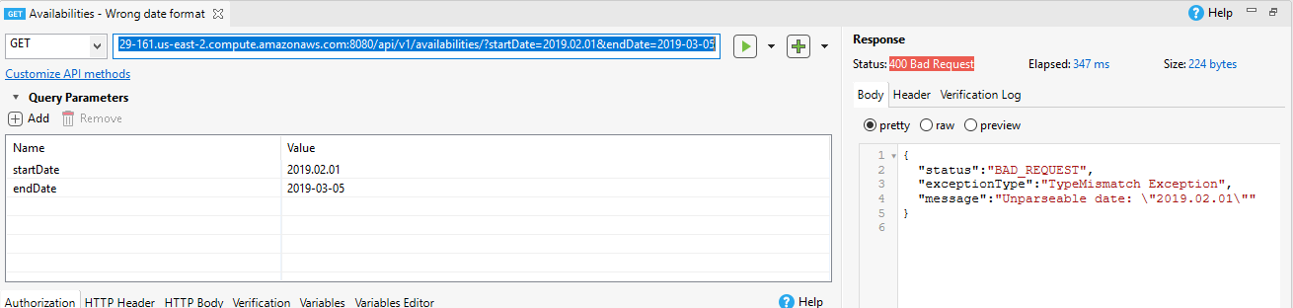

Test case 3: Return properly available dates

Requirement
The objective of this API is return the real available dates to be reserved to avoid overlaps and duplication, this test case will test if the API can return just available dates, avoiding reserved ones.

Expected result

Scenario: The system has just one reservation active at this moment with the booking identifier xA7PanKw. The reservation starts at 2019-04-01 and ends 2019-04-03. The test will request reservation starting 2019-04-02 and ending 2019-04-04. The expected available date result should be just 2019-04-04, because 2019-04-02 and 2019-04-03 are reserved already under booking identifier xA7PanKw, as you can see a screenshot from data base:

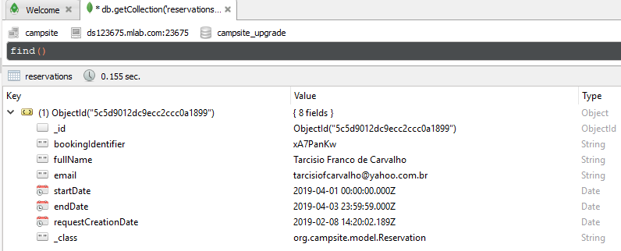
- HTTP status code: 200 OK
- JSON response:
{
"availableDate":["2019-04-04T00:00:00.000+0000"]
}

Actual result
- Execution date: 2019-02-10 11:26
- API URI: http://ec2-3-17-129-161.us-east-2.compute.amazonaws.com:8080/api/v1/availabilities/?startDate=2019-04-02&endDate=2019-04-04
- Result: Passed
- Screenshot:

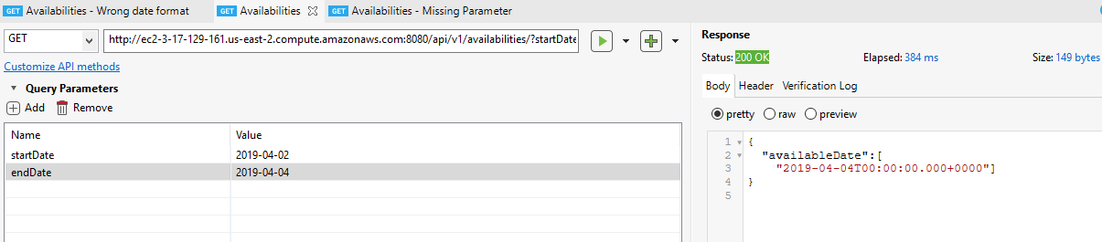

campsite reservation api test cases
The objective of the reservation API is to provide endpoint resources to request a reservation, request a reservation update and cancel a reservation.

Test case 1: Max reservation days exception

Requirement
It is a business requirement where the request range cannot be more than 3 days, otherwise the API should return a clear exception error message.

Expected result
- HTTP status code: 406 Not acceptable
- JSON response:
{
"status":"NOT_ACCEPTABLE",
"message":"You are request exceed the limit max 3 days of reservation. Please adjust your request",
"errors":[
"Max Reservation Days Exception"]
}

Actual result
- Execution date: 2019-02-10 11:37
- API URI: http://ec2-3-17-129-161.us-east-2.compute.amazonaws.com:8081/api/v1/reservations/
- Result: Passed
- JSON response:
{
"fullName" : "Tarcisio Franco de Carvalho",
"email": "tarcisiofcarvalho@yahoo.com.br",
"startDate": "2019-03-05",
"endDate": "2019-03-09"
}

- Screenshot:

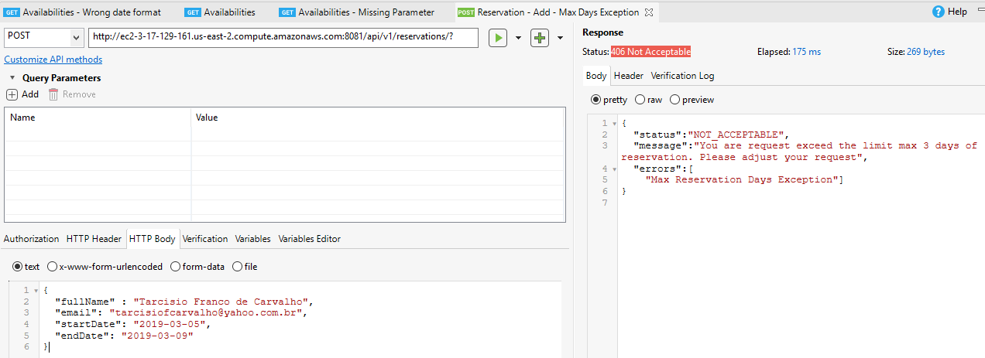

Test case 2: Request reservation for minimum 1 day(s) ahead of arrival and up to 1 month in advance

Requirement
It is a business requirement where the campsite can be reserved minimum 1 day(s) ahead of arrival and up to 1 month in advance.

Expected result
- HTTP status code: 406 Not Acceptable
- JSON response:
{
"status":"NOT_ACCEPTABLE",
"message":"The campsite can be reserved minimum 1 day(s) ahead of arrival and up to 1 month in advance. Please adjust your request",
"errors":[
"Reservation Request Time Limited Exception"]
}

Actual result
- Execution date: 2019-02-10 11:44
- API URI: http://ec2-3-17-129-161.us-east-2.compute.amazonaws.com:8081/api/v1/reservations/
- Result: Passed
- JSON passed:
{
"fullName" : "Tarcisio Franco de Carvalho",
"email": "tarcisiofcarvalho@yahoo.com.br",
"startDate": "2019-03-12",
"endDate": "2019-03-14"
}
- JSON response:
{
"status":"NOT_ACCEPTABLE",
"message":"The campsite can be reserved minimum 1 day(s) ahead of arrival and up to 1 month in advance. Please adjust your request",
"errors":[
"Reservation Request Time Limited Exception"]
}

- Screenshot:

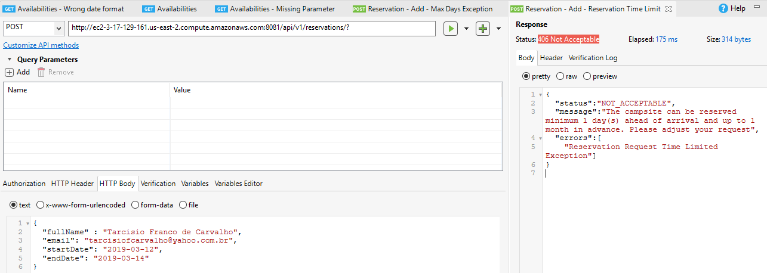

Test case 4: Passed a non-valid booking identifier exception

Requirement
This requirement is related to request reservation update or cancelation when is passed a non-valid booking identifier number. The API should return a clear message about the exception

Expected result
- Scenario: The unique reservation at this moment in the database is the booking identifier xA7PanKw. The API should return an exception message when passed a different booking identifier
- HTTP status code: 400 Bad Request
- JSON response:
{
"status":"BAD_REQUEST",
"message":"The booking identifier: <bookingId> is not valid, please verify.",
"errors":[
"Invalid Booking Identifier Exception"]
}

Actual result
- Execution date: 2019-02-10 11:59
- API URI: http://ec2-3-17-129-161.us-east-2.compute.amazonaws.com:8081/api/v1/reservations/AAAbbb1
- Result: Passed
- JSON passed:
{
"fullName" : "Mariane Beatriz Miranda de Carvalho",
"email": "mbm@br.ibm.com",
"startDate": "2019-03-04",
"endDate": "2019-03-06"
}

- JSON response:
{
"status":"BAD_REQUEST",
"message":"The booking identifier: AAAbbb1 is not valid, please verify.",
"errors":["Invalid Booking Identifier Exception"]
}

- Screenshot:

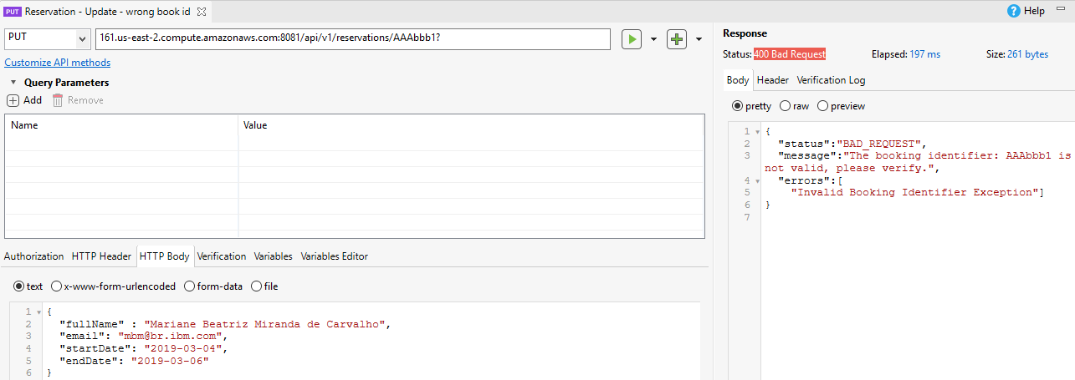

Test case 5: Requested reservation dates not available exception

Requirement
This is the most important requirement to avoid duplicated reservations during the request. The API should return a clear message with exactly not available dates

Expected result
- Scenario: To reproduce the case, was created a new reservation from 2019-03-01 to 2019-03-03 under booking number r3G34K70. This test will request a reservation from 2019-03-03 to 2019-03-5. The API should return a message saying that 2019-03-03 is already reserved

- HTTP status code: 400 Bad Request
- JSON response:
{
"status":"NOT_ACCEPTABLE",
"message":"The date(s) : [\"Mar 3, 2019 3:00:00 AM\"] are not available for your reservation. Please adjust your request",
"errors":["Reservation Dates not Available Exception"]
}

Actual result
- Execution date: 2019-02-10 12:13
- API URI: http://ec2-3-17-129-161.us-east-2.compute.amazonaws.com:8081/api/v1/reservations?
- Result: Passed
- JSON passed:
{
"fullName" : "Tarcisio Franco de Carvalho",
"email": "tarcisiofcarvalho@yahoo.com.br",
"startDate": "2019-03-03",
"endDate": "2019-03-05"
}

- JSON response:
{
"status":"NOT_ACCEPTABLE",
"message":"The date(s) : [\"Mar 3, 2019 3:00:00 AM\"] are not available for your reservation. Please adjust your request",
"errors":[
"Reservation Dates not Available Exception"]
}

- Screenshot:

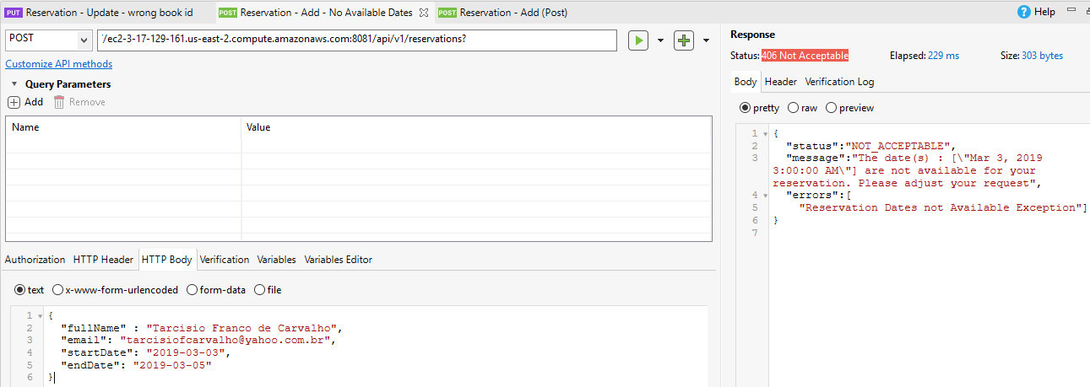

Test case 6: Request reservation

Requirement
Create reservation and return the reservation fields and booking identifier

Expected result
- HTTP status code: 200 OK
- JSON response:
{
"id":{
"timestamp":<value>",
"machineIdentifier":<value>,
"processIdentifier":<value>,
"counter":<value>,
"time":<value>,
"date":"yyyy-MM-ddTHH:mm:ss.000+0000",
"time Second":<value>
},
"bookingIdentifier":"<value>",
"fullName":"<value>",
"email":"<value>",
"startDate":"YYYY-DD-MMT00:00:00.000-0300",
"endDate":"YYYY-DD-MMT20:59:59.000-0300",
"requestCreationDate":"YYYY-DD-MMTHH:mm:ss.004+0000"
}

Actual result
- Execution date: 2019-02-11 14:15
- API URI: http://ec2-3-17-129-161.us-east-2.compute.amazonaws.com:8081/api/v1/reservations?
- Result: Passed
- JSON passed:
{
"fullName" : "Tarcisio Franco de Carvalho",
"email": "tarcisiofcarvalho@yahoo.com.br",
"startDate": "2019-02-12",
"endDate": "2019-02-14"
}

- JSON response:
{
"id":{
"timestamp":1549901676,
"machineIdentifier":13231996,
"processIdentifier":1,
"counter":7155129,
"time":1549901676000,
"date":"2019-02-11T16:14:36.000+0000",
"timeSecond":1549901676
},
"bookingIdentifier":"Vv54EgGP",
"fullName":"Tarcisio Franco de Carvalho",
"email":"tarcisiofcarvalho@yahoo.com.br",
"startDate":"2019-02-12T00:00:00.000-0300",
"endDate":"2019-02-14T20:59:59.000-0300",
"requestCreationDate":"2019-02-11T16:14:37.004+0000"
}

- Screenshot:

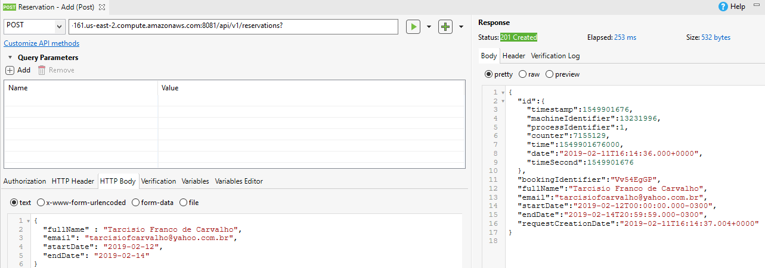

Test case 7: Request reservation update

Requirement
Update the reservation and return the HTTP 200 OK code

Expected result
- HTTP status code: 200 OK

Actual result
- Execution date: 2019-02-11 15:39
- API URI: http://ec2-3-17-129-161.us-east-2.compute.amazonaws.com:8081/api/v1/reservations/Vv54EgGP
- Result: Passed
- JSON passed:
{
"fullName" : "Tarcisio Franco de Carvalho",
"email": "tarcisiofcarvalho@yahoo.com.br",
"startDate": "2019-02-13",
"endDate": "2019-02-15"
}

- Response: HTTP 200 OK

- Screenshot:

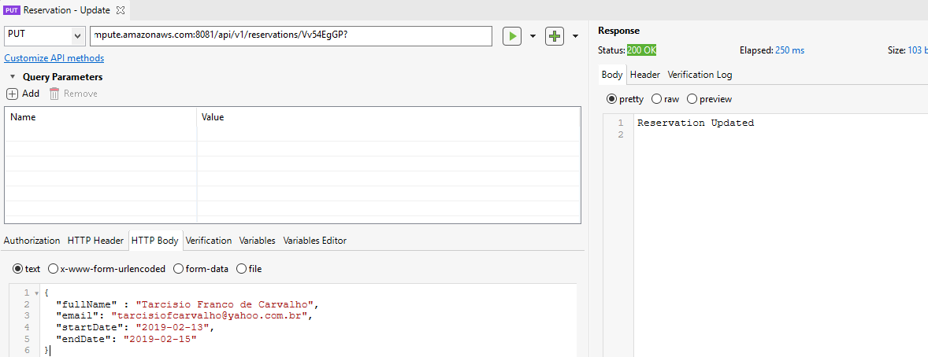

Test case 7: Cancel reservation

Requirement
Cancel the reservation and return the HTTP 200 OK code

Expected result
- HTTP status code: 200 OK

Actual result
- Execution date: 2019-02-11 15:43
- Result: Passed
- API URI: http://ec2-3-17-129-161.us-east-2.compute.amazonaws.com:8081/api/v1/reservations/Vv54EgGP
- Path variable passed: Vv54EgGP
- Response: HTTP 200 OK

- Screenshot:

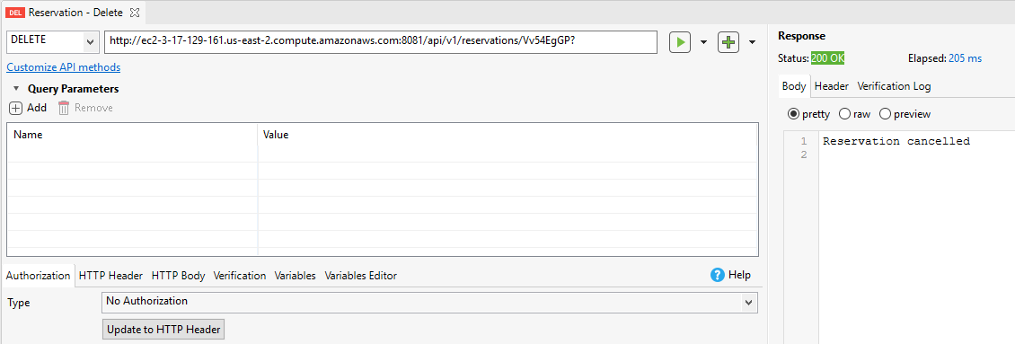

Test case 8: Multiple reservation requests for the same/overlapping date

Requirement
The system should be able to handle multiple reservation requests avoiding the same reservation data creation or overlapping.

Expected result
The reservations request below should not be overlapping or duplicated, for overlapping or duplicated requests the API should return HTTP code 406.

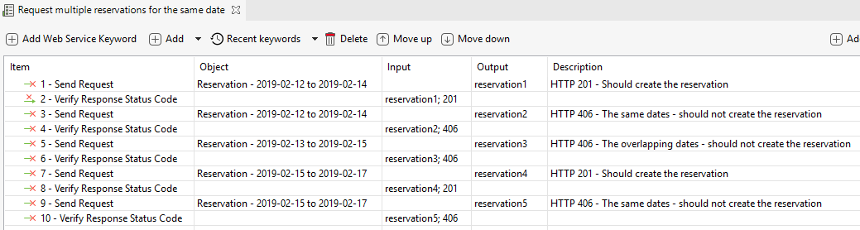

Just reservation request on step 1 (Reservation from 2019-02-12 to 2019-02-14) and step 7 (Reservation 2019-02-15 to 2019-02-17) should be created. The reservation request on steps 3, 5 and 9 should be not created returning HTTP code 406

Actual result
- Execution date: 2019-02-11 17:09
- Result: Passed
- Test execution log:
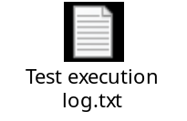
- Screenshot:

